WD Blue SN580 NVMe™ SSD 500GB WDS500G3B0E PCIe Gen4 x4 M.2 2280

(CZONE)

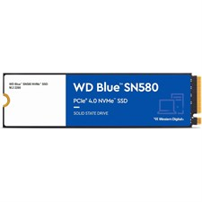

**Key Features**

* **Model**: WDS500G3B0E
* **Capacity**: 500GB
* **Form Factor**: M.2 2280
* **Interface**: PCIe Gen4 x4 (Backward compatible with PCIe Gen3)
* **NAND Type**: 3D NAND
* **Sequential Read Speed**: Up to 3,500 MB/s
* **Sequential Write Speed**: Up to 2,900 MB/s
* **Endurance**: 200 TBW (Total Bytes Written)

**Performance Features**

* **PCIe Gen4 x4 Interface**: The WD Blue SN580 leverages the latest **PCIe Gen4 x4** interface to deliver blazing fast data transfer speeds, providing significant improvements over SATA-based SSDs. With speeds up to **3,500 MB/s** read and **2,900 MB/s** write, it ensures faster boot times, quicker file transfers, and responsive gaming experiences.

Software and Support

* **Limited Warranty**: The WD Blue SN580 SSD comes with a **5-year limited warranty**, providing users with long-term peace of mind regarding the drive's reliability and performance.